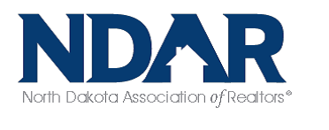

**Public**

**Policy**

**Statement**

North Dakota Association of REALTORS®

1616 Capitol Way

Bismarck, ND 58501

[info@ndrealtors.com](mailto:info@ndrealtors.com)

www.ndrealtors.com

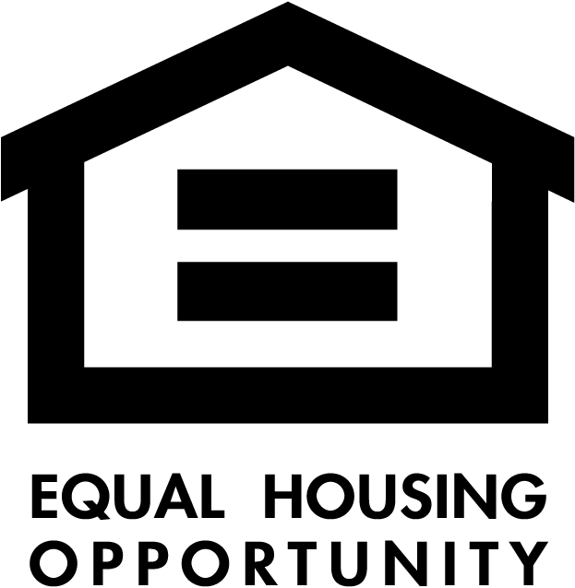

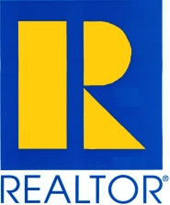

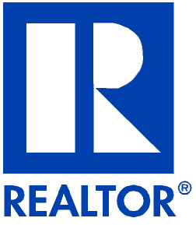

***VISION***

*The North Dakota Association of REALTORS®*

*is the trusted voice of real estate and*

*the advocate for a better real estate future.*

***MISSION:***

*To advocate for the success of our members in partnership with our local Associations and the National Association of REALTORS®*

NORTH DAKOTA ASSOCIATION OF REALTORS®  PUBLIC POLICY STATEMENT – 2025/2026

The social and economic fabric of our nation, and our state, is deeply rooted in the fundamental right of all people to own, use, and transfer real property. Real property ownership has been and continues to be one of the highest personal priorities of most Americans.  Real property is defined as land and anything permanently affixed to the land together with all rights exercisable in connection with such land and fixtures.

Real property ownership inspires a deep sense of personal pride and accomplishment and fosters greater interest and involvement in community affairs. Real property ownership encourages savings and investment and contributes to economic stability and self-sufficiency.

The ND Association of REALTORS® is committed to the protection and preservation of the constitutional right of every individual to acquire, occupy, use and dispose of real property as he or she chooses within the law. We oppose all laws, rules, and regulations that impose unreasonable restraints and limitations on the private ownership, use, and transfer of real property. This includes inequitable and counterproductive property and real estate-related taxes.

We are further committed to the protection and preservation of the free enterprise system. We oppose undue government intervention in the affairs of private businesses and look unfavorably upon government guidelines, rules, regulations, and procedures that unnecessarily burden the business community and add to the costs of doing business.

1. **PROPERTY AFFORDABILITY**

1.1 The ND Association of REALTORS® believes that each person should have the opportunity to live in safe and decent housing which our North Dakota families and individuals can afford. We urge all levels of government to adopt and integrate housing policies that are responsive to the individual and collective housing needs of our society.

1.2 The Association believes that North Dakota housing needs and objectives are best served in an economically healthy private market. We support legislative measures and initiatives that serve to increase the availability and affordability of housing through the private sector. We favor government intervention and public assistance only when housing needs cannot be fully or effectively met by the private sector.

1.3 The Association favors joint public and private sector housing initiatives that encourage homeownership by individuals and families at all income levels.

1.4 The Association strongly supports the existence of a North Dakota State Housing Finance agency to advocate and administer state housing policies and programs.

1.5 The Association believes that rental housing needs are best met through private investment. We encourage and support measures that accomplish this objective.

1.6 The Association believes that real estate investment, development, and revitalization contribute to a sound economic base and an adequate supply of housing which all ND citizens can afford. We oppose state and local policies and regulations that limit or effectively prevent innovation and development that serve to meet housing needs and changing market demands.

1.7 The Association believes that local planning and zoning policies should allow for development of adequate housing which all families and individuals can afford. We support laws and policies which:

* zone adequate land for all types of housing
* allow growth in residential, commercial and industrial development
* streamline the permit and approval process and eliminate unnecessary and costly time delays
* encourage innovations in development and construction techniques and materials
* encourage innovative product design to meet affordable housing needs

1.8 The Association opposes adoption of laws and policies that allow public or private impact or transfer fees on real property. Such fees discourage development and add to the cost of real property acquisition.

1.9 The Association recognizes that factory-built housing, manufactured housing and other types of non-stick built housing provide an affordable alternative to traditional types of housing and expand ownership opportunities for people in North Dakota.

1.10 The Association advocates local control of planning and zoning policies that encourage the development and availability of all housing types including manufactured housing. (See sections 1.6 and 1.7).

**2. GOVERNMENT REGULATION**

2.1 The ND Association of REALTORS® believes that competition in a free enterprise system is the best way to meet the needs and market demands for real property. We urge government at all levels to reduce impediments which prevent the private sector from meeting the needs and demands for real property more efficiently and effectively.

2.2 The Association strongly opposes exclusionary zoning, no-growth ordinances and moratoriums as such laws and policies limit the supply of housing, restrict economic and investment opportunities, and contribute to higher housing costs.

2.3 The Association believes that government at all levels should be efficient, responsive and economical.  We support and encourage the cooperation and regionalization of governmental entities in sharing provision of services so as to avoid duplication and cut costs.

2.4 The Association believes that government regulatory procedures affecting real property should be simplified. Unnecessary and complex regulations delay real property transactions and increase costs associated with the transfer and use of real property.

2.5 The Association advocates just reimbursement and demonstrated proven need as unconditional requirements for the confiscation of private property by the government. We oppose unreasonable confiscation.

2.6 The Association supports efforts to keep homeowners in their homes through housing rehabilitation and the use of smart technology.

**3. TAXATION**

3.1 While we realize the importance of many Government programs funded through property tax, we believe tax revenues should be equitably collected from other sources. Real property should only be taxed for the actual services it receives (i.e. law enforcement, fire protection, appropriate administrative fees etc.)

3.2 The Association favors a tax system that fosters economic growth and healthy real estate markets. We oppose any primary residence property tax freeze that negatively impacts decisions about homeownership and ownership of real property.  We encourage public support of homeownership and real estate investments through income tax advantages. We support income tax deductions that encourage private investment.

3.3 The Association believes that government fees should not exceed the reasonable cost of providing the service for which the fee is charged. We oppose an increase of government fees leading to the surreptitious increase of taxes.

3.4 Recording fees. The Association believes that Government recording and document fees should not exceed the actual cost of recording or document preservation expenses.

3.5 Speculation Taxes. The Association opposes the taxation of capital gains realized on the sale of real property.

3.6 Taxes on Services. The Association continues to oppose any effort to impose a sales tax on real estate brokerage services or on any other real estate-related services (e.g., tax on commission fees, rental fees, appraisal fees, tax on advertising, etc.)

**4. ENVIRONMENTAL PROTECTION**

4.1 The Association opposes unreasonable restriction on the use of privately owned property including shore land zone controls, open space requirements, protection of public/private water supplies, moratoriums and no growth policies that have adverse economic effects on employment, housing and the tax base. The Association urges all levels of government to respect the concept that private property ownership is made up of a bundle of rights, which includes use. If such use is denied or abridged by government for the benefit of the people, the cost of "taking" should be equitably distributed. The individual property owner should not be expected to pay for measures that benefit the public good and a broad number of citizens and which, in effect, limit the individual’s private property rights.

4.2 The Association urges collective and cooperative action by lawmakers, government representatives, general industry and real estate industry leaders, and environmental groups to address and resolve the problems and challenges of environmental protection and responsible land use.

**5. ENERGY CONSERVATION**

5.1 The ND Association of REALTORS® supports voluntary energy conservation measures including favorable financing for costs incurred to reduce energy consumption.

5.2 The Association supports the development and voluntary use of alternative energy sources to reduce dependence on non-renewable forms of energy.

5.3 The Association opposes mandatory energy audits or mandatory energy ratings for real property, but supports voluntary energy audits to assist in decisions to purchase property or upgrade efficiency.

5.4 4.1 The ND Association of REALTORS® supports protection and preservation of North Dakota’s environment and natural resources provided economic development, accessibility of housing for all ND citizens and private property rights are not overly and unreasonably restricted.

**6. AGENCY**

The Association supports agency disclosure on single-family residential and 1-4 unit multi-family properties that requires that all licensees provide timely, written disclosure which lists agency relationships available under state law. “Agency” is defined as the relationship that results when one person authorizes another to act on his/her behalf, subject to his/her control, and the other person consents to act as his/her agent.

**7. LICENSE LAW AND REAL ESTATE PRACTICE**

7.1 The Association supports and endorses real estate brokerage licensing laws and regulation. We support the existence of a competent and adequately funded state Real Estate Commission to oversee the business and professional conduct of real estate licensees.

7.2 The Association believes that real estate brokerage license laws and regulations must reflect the practical demands and dynamics of real estate brokerage practice and business operation.

7.3 The Association advocates professionalism and competency in real estate brokerage practice through formal and informal education, training and research. We support mandatory pre-licensure education and mandatory continuing education for all licensees.

7.4 The Association supports use of technology as part of real estate practice including Internet, digital and smart device communications.

**8. FAIR HOUSING**

8.1 The ND Association of REALTORS® acknowledges and supports the right of all people to freely choose where they will live, regardless of race, color, religion, sex, disability, handicap, familial status, national origin, sexual orientation, or gender identity, or status with respect to marital status or receipt of financial assistance. This right is protected under federal and/or state fair housing laws and is a standard of practice of the *Code of Ethics of the National Association of REALTORS®.*

8.2 The Association believes that equal opportunity in housing can best be achieved through observance of the law, public and industry education, and mutual cooperation of the real estate brokerage industry and the public in a free and open housing market.

**9. CONSUMER PROTECTION**

9.1 The ND Association of REALTORS® supports and encourages dissemination of information which helps buyers, sellers, lessors, lessees, and other parties in a real estate transaction know and understand

their rights and obligations as clients and customers, such as Agency Disclosure forms or Property Condition statements from the seller.

9.2 We recognize the importance of professionalism of home inspectors, appraisers, assessors and other real estate related professions that may include registration, certification, mandatory education, and standards of conduct.

**10. ANTITRUST COMPLIANCE**

10.1 The ND Association of REALTORS® believes that vigorous and fair competition is essential to the preservation of our free enterprise system. We advocate strict compliance with federal and state antitrust laws.

10.2 The Association recognizes that compensation is a matter of individual agreement between broker and client and that any individual or collective attempt to fix, set, or control rates of compensation by the association or any of its members is a violation of federal and state antitrust law.

**11. GOVERNMENT & POLITICAL AFFAIRS**

11.1 The ND Association of REALTORS® supports the purpose and objectives of political action committees and the REALTOR® Party and will continue to operate and encourage the activities of the ND Association of REALTORS® Political Action Committee (ND RPAC) and Political Action Fund (ISSUES & MOBILIZATION).

11.2 The Association urges its members to work diligently toward effecting more efficient, responsive and economic government at all levels. We encourage the involvement of REALTORS® in local, state, and national government and political activities as a means of achieving public policies and laws which preserve and protect the economic interests of the real estate industry and the right of all people to own, use and transfer real property.

*Approved and adopted by the ND Association of REALTORS®: October 7, 2010*

*Amended and adopted by the ND Association of REALTORS®: July 24, 2014*

*Amended and adopted by the ND Association of REALTORS®: January 4, 2017*

*Reviewed and accepted by the ND Association of REALTORS®, June 13, 2018*

*Amended and adopted by the ND Association of REALTORS®, June 2022*

*Amended and adopted by the ND Association of REALTORS®, January 2025*

For more information contact:

**NDAR**

**701-355-1010 or Jill@ndrealtors.com**